_Laravel_

STRUCTURE Development DOCUMENTATION

INDEX

1. Controllers
   1. Constructor
   2. Index
   3. Show
   4. Create
   5. Edit
   6. Store
   7. Update
   8. Destroy
2. Models
   1. Table name
   2. Fillable
   3. Fetch records
   4. Store / Update records
   5. Destroy record
3. **Controllers**: All controller files are stored under the App\Http\Controllers folder, and all API controller 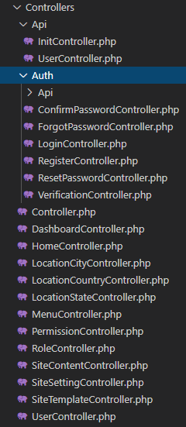 files are stored under the App\Http\Controllers\Api folder. There are some pre-installed controllers that exist to build this application.   
     
     
   Make the same name for API controllers. Such as UserController.  
     
     
   Please extend your controller from App\Http\Controllers\Controller.